LeDinhAn | August 19, 2015

Game Ocean Ring Toss

Product report

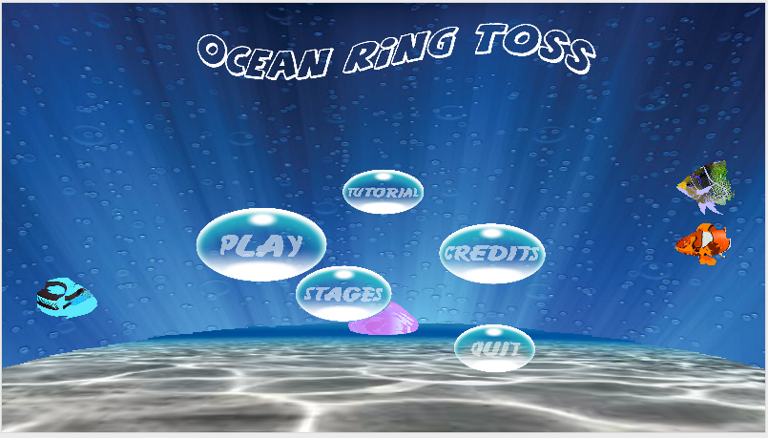

# Reason for writing the report:

The report is written in order to describe the game product of our team, “Ocean Ring Toss” and the process of making and developing the game. The report also describes obstacles and problem we have encountered since our team started the project.

# Game background:

The game is made and developed to response to the given task from the company Gameloft during the internship course.

# Game description:

## General description:

“Ocean Ring Toss” is the game which runs in the Android operating system. The game is inspired from children’s toy, water ring toss. The gameplay of the game is similar to that of the original water ring toss toy. There are 3 levels that player needs to finish in order to win the game.

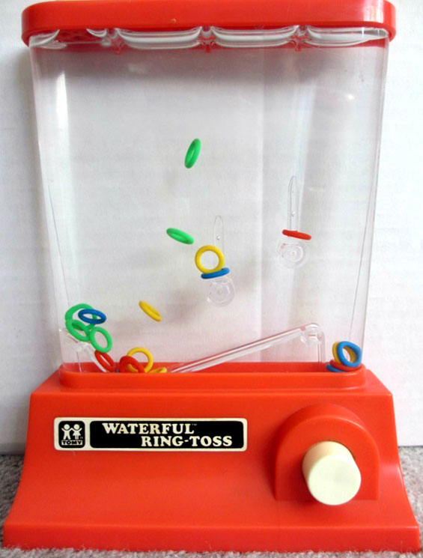

Figure Water Ring Toss Toy

## Gameplay description:

The gameplay is similar to the original. In the game, the smart will be used as the water ring toss box. There are 2 water guns on the screen. Tapping gun will create a force that will push the rings up. The task is to make the given number of the rings in to pillars that are attached at the background. In order to complete the task, player can use the forces generated by the guns or use the other forces generated, for example, by gravity or by shaking in a given time. There are 3 levels that player needs to accomplish in order to win the game. The result from each level will be evaluated by time player uses to complete the task. The less time player uses, the higher the score player gets. The result of the task will be represented with stars. The maximum number of stars player can get in a level is three, the next one player can get is two and the minimum is one. Player can get these stars if he or she can complete the task in a defined amount of time. The time player has left is shown by the time bar at the top of the play screen. After finish a level, the game result is saved automatically.

### Stage 1:

To complete stage 1, player has to put 2 of the given rings to the two fixed pillars in a given amount of time.

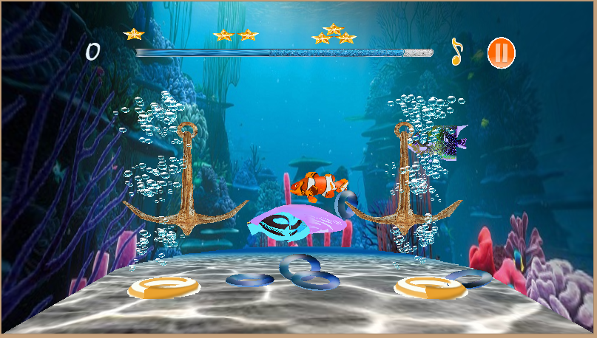

Figure Stage 1

### Stage 2:

To complete stage 2, player has to put 5 of the given rings to the pillars, one of which is moving in a given amount of time.

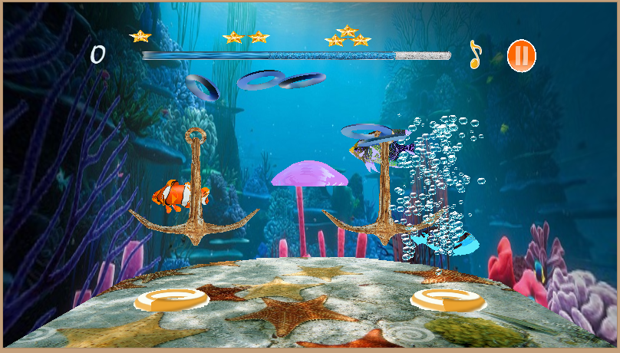

Figure Stage 2

### Stage 3:

To complete stage 3, player has to put all 5 given rings to the two moving pillars in a given amount of time.

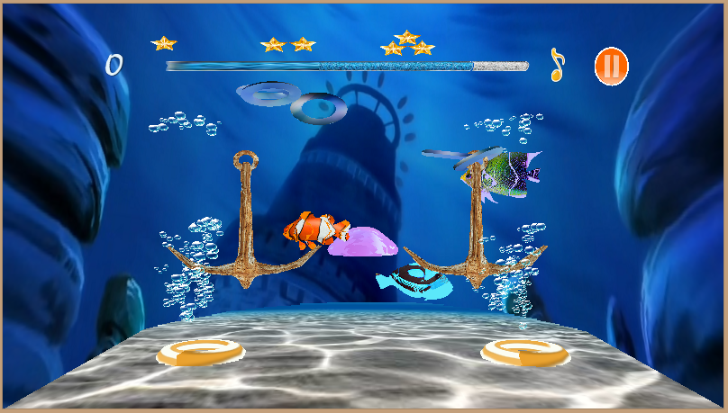

Figure Stage 3

## user interface (ui) description:

There are two main interfaces in the game: the main menu scene and the gameplay scene.

### Main menu interface:

The main menu interface has five buttons: Play button, Tutorial button, Credits button, Quit button and Stages button. Tapping the Play button leads player to the game play interface, tapping the Quit button help player exit the game and tapping Stages button leads to the stages menu. Choosing Tutorial and Credits show player how to play the game and developers’ contact information respectively.



Figure Main Menu Demo

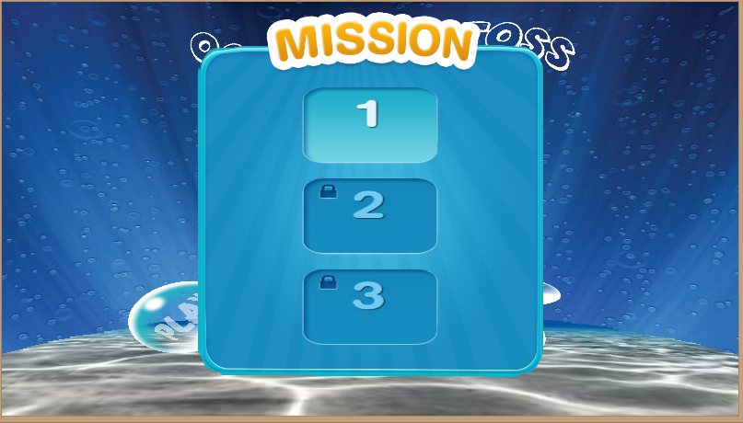

Figure Select Stages Demo

### Gameplay interface:

The gameplay screen is horizontal. There are two water guns at the bottom of the screen. A force is generated by tapping the guns. Each guns is at each bottom corner of the screen. There is time bar at the top the screen, which is used to represent time. There also are stars on the bar which show how many points left player has. There are pause and sound button at the right top corner of the screen. The background music is stopped if the music icon is tapped. If the pause button is tapped, a pause menu will appear and options will be showed. There are menu option, resume option and restart option in the pause menu. The menu option help player to go to the main menu interface, the resume option lets player to continue the game and the restart option helps player to replay the stage. When the time runs out, a menu box will pop up and announce that the mission is failed, and options will be shown in the mission failed box. These option are restart option and menu option. When player finishes a stage, a mission completed box will appear and shown options. These options are retry option, which lets player to replay the stage, and next option, which lets player to go to the next stage of the game.

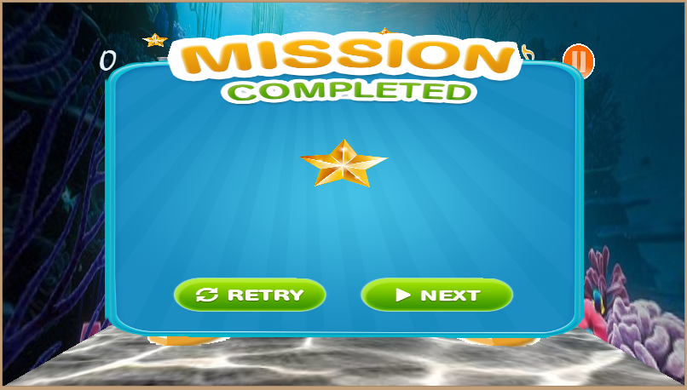

Figure Menu Win

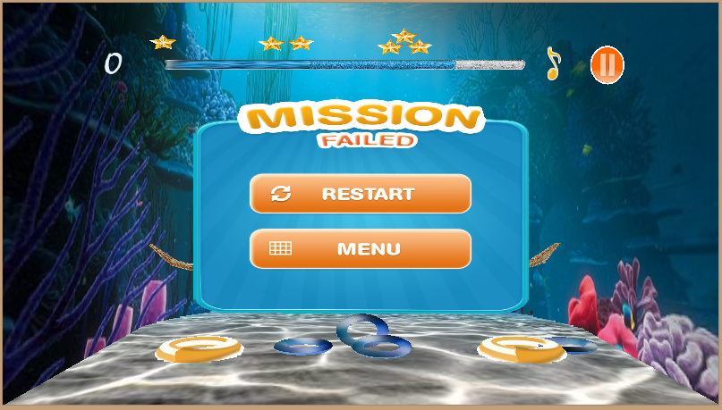

Figure Menu Lose

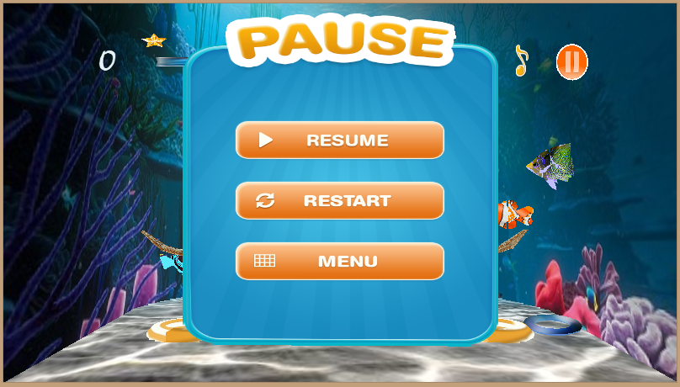

Figure Menu Pause

## functions description:

### Turn on or off the background music:

Player can turn on or off the background music during the game by tap music note icon.

### Choosing stages to play:

After having finished a level, player can replay the level by going to the level menu and choose an unlocked level.

### Tutorial:

There is a tutorial option. This is for instructing player how to play the game and how to use given functions in the game.

### Credits:

Player can use this function to get contact information of the game’s developers.

### Pause:

Player use this function during the game to pause the game.

# Difficulties and problems encountered

During the game making process, we have encountered some problems. We, at first, met some problems in applying physics library, Bullet Physic, in our game. Because the game is based from children’s water ring toss toy, the physics in game must be similar to that in reality, and the game developers must be concerned to the classical mechanics’ properties. However, we eventually manage on applying the library. Nevertheless, we met some problems in designing models and transparent textures for bubbles and glass transparent time bar because we lack of graphic designers in our team. To solve these problem, we use some models and texture available on the Internet and use Photoshop and Blender to adjust these resource so that they meet our need. We also met difficulties in porting our game from Win 32 to Android, but the problems have been solved.

# Further development

The game is still not realistic. The game still does not have the frictional force between objects. Frictional properties needs adding to the game to make it more realistic. Moreover, there are still bugs in the game which need fixing, for example the ring in pillar checking is still not stable, bubbles sometimes does not appear after a water gun has been tapped.